
Deployment and Operations (Dep/Ops) Guide (Runbook)

MailSpeak Application (MSA)
University of Maryland Global Campus (UMGC)
Software Engineering (SWEN) 670
Fall Cohort 2022
Team B
November 5, 2022
Document Control

Document Information
© | Information
Document Id | USPS-MSA-DOG-20221029-Fall2022
Document Owner | UMGC SWEN 670
Issue Date | October 29, 2022
Last Saved Date | November 5, 2022
File Name | DOG - Team B - MSA.docx

Document History
Version | Issue Date | Changes
0.1 | 9/18/2022 | Initial Draft
0.2 | 10/29/2022 | Review Updates
1.0 | 10/29/2022 | Final Deliverable
1.1 | 10/30/2022 | References style and document suite updates
1.2 | 11/4/2022 | Feedback updates
2.0 | 11/5/2022 | Final deliverable

Table of Contents
1 Introduction 5
1.1 Purpose 5
1.2 Intended Audience 5
1.3 Scope 5
1.4 Project Documents 5
1.5 Document References 6
1.6 Identify Stakeholders 6
2 Development Team Workflow 6
2.1 Description of Deployment 6
2.2 Points of Contact 7
2.3 Deployment Schedule 8
3 Mobile Application 8
3.1 Features, Packages, and Plugins 8
3.1.1 Features 8
3.1.2 Packages 8
3.1.3 Plugins 8
4 Software Installation 9
4.1 Android Studio 9
4.2 Flutter and Dart 12
4.3 Android Emulator 13
4.4 GitHub Desktop 14
5 Prepare Mobile Application for Use 15
5.1 Cloning the GitHub Repository 15
5.2 Run the Flutter Application 15
5.3 Setting up an Android Device 15
5.4 Setting up an iOS Device 17
6 Deployment, Testing and Release of the Mobile Application 20
6.1 Google Play Store (Android) 20
6.1.1 Deploying to Google Play Store (Android) 20
6.1.2 Promoting Releases 21
6.1.3 Viewing Errors with Release 22
6.2 App Store Connect (iOS) 23
6.2.1 Deploying to App Store Connect (iOS) 23
6.2.2 Testing 28
7 Troubleshooting 33
7.1 Emulator Freezing 33
7.2 Emulator Not Responding 33
7.3 Out of Memory 34
7.4 Dependency Errors 34
Appendices 35
Appendix A – Acronyms and Abbreviations 35
Appendix B – Enabling Screen Reader on Android Device 36
Appendix C – Enabling Screen Reader on iOS Device 37

Introduction
The following Deployment and Operations Guide (DOG) will detail a set of instructions for the process of installing and deploying the MailSpeak application designed as part of the UMGC Fall 2022 Cohort. The guide will detail how to install the application on a user’s device and provide instructions of each step to configure the application for use.

Purpose
This Deployment and Operations Guide (Runbook) describes how the system will be deployed and transitioned to a Production environment for all installation sites. Specifically, the Deployment Plan:
- Describes the major activities for deploying the system, including the objective of each activity, required resources, key personnel, and completion criteria.
- Presents the schedule for deploying the system.
- Describes system security features and security requirements for system deployment.
- Identifies required implementation support, including personnel, hardware, software, facilities, and materials.
- Designates the production sites at which the system will be deployed and describes how the system will be installed at the production sites.
- Presents the schedule for developing and testing recoverability prior to production implementation.

Intended Audience
The intended audience for the deployment and operations guide (DOG) is the technical project team and stakeholders. This document will provide necessary guidelines on what is included within the application, how to deploy the application, and how to test the application.

Scope
The scope of this document details the processes involved with deploying the application from the developer’s local environment all the way to the production environment, as well as the steps to configure these environments to properly run the application for testing and usage. This document is limited to only mobile application development via iOS and Android as those are the current target platforms for this iteration of product development.

Project Documents
This DOG is part of a set of essential documents created to adequately manage, control and deliver the MailSpeak Application. Artifacts that are provided within the document package contain vital information for the application’s ongoing support and operation throughout its life cycle. Each document is created within the specific Milestone of the project. Therefore, the version and date of some documents could be marked as “to be determined” (TBD) in Table 1.4.1.
Table 1.4.1 - Project Documentation Package
Document | Version | Date
Project Management Plan (PMP) | 4.0 | 11/05/2022
Software Requirements Specification | 4.0 | 11/05/2022
Technical Design Document | 3.0 | 11/05/2022
Software Test Plan | 3.0 | 11/05/2022
Programmer Guide | 2.0 | 11/05/2022
Development and Operations Guide | 2.0 | 11/05/2022
User Guide | 1.0 | 11/05/2022
Test Report | 1.0 | 11/05/2022

Document References
During the process of writing current Development and Operations Guide the following documents were referenced:
- Team B. (2022). United Global Master Coders Team B PMP. https://umgcdev361.sharepoint.com/:w:/r/sites/SWEN670Fall2022/Shared%20Documents/Team%20B%20Channel/Milestone%201%20(SAT%20SEP%203)/ProjectManager-Project-Plan-Template.docx?d=w671384dfe89d46d7a2583b60416fb909&csf=1&web=1&e=xeRN2o

Identify Stakeholders
Table 1.6.1 - Project Stakeholders
Stakeholder Name | Project Role
Mir Assadullah | Professor, Program Manager
Roy Gordon | Project Mentor
Robert Wilson | DevSecOps Mentor
Alexander Chan | Software Engineer (SE) II
Andrew Asavarungsrikul | Software Engineer (SE) I
Erin Sauter | Software Engineer (SE) I
Jonay Simmons | Software Engineer (SE) I
Lawrence Van Tassel | Software Engineer (SE) III
Michael Conatser | Project Manager (PM), Scrum Master
Minyahil Kebebegn | Software Engineer (SE) II
Sarah Johnson | Software Engineer (SE) I
Shane Knowles | DevSecOps Engineer (Principal)
Tatiana Kozhevnikova | Product Owner
TraMel Perry | Principal Software Engineer (SE)

Development Team Workflow

Description of Deployment
Using GitHub, developers will branch from the repository to develop the features to be added to the previously developed MailSpeak application. Once development and unit testing has completed on the feature branch, the developer will submit a pull request, which must be reviewed by two other members of the team. Upon completion of this pull request, a CI/CD pipeline for iOS and Android will be run using Github Actions. The pipeline will assign a Build Identification Number and populate any secrets defined in the repository, setup Flutter and install any dependencies, and then generate the desired artifact(s). Once the artifact is built, the pipeline will run unit tests that must succeed before the application can be released to the test track for the AppStore/PlayStore (developer branch only). All stages must complete successfully, in addition to needing the approval of two team members, before a Pull Request can be merged into the developer branch. Once merged into the developer branch, the CI/CD pipelines will be triggered again and release the artifact to their respective store for Pre-Production testing.
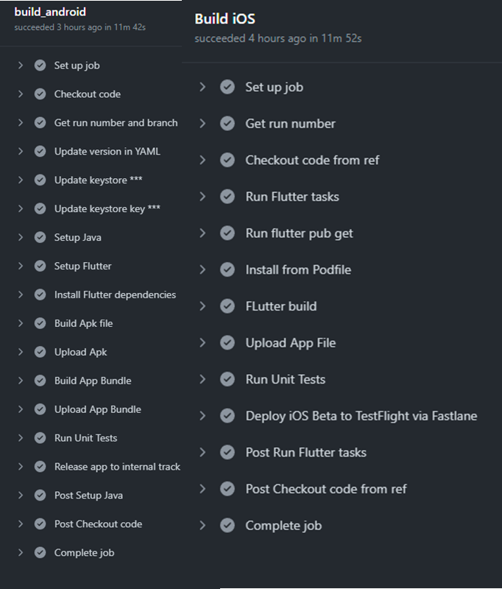
Figure 2.1.1 - CI/CD Pipelines for GitHub Actions

Points of Contact
Table 2.2.1 - Points of Contact
Name | Project Role
Mir Assadullah | Professor, Program Manager
Roy Gordon | Project Mentor
Robert Wilson | DevSecOps Mentor
Robert Dixon | Project Sponsor
Alexander Chan | Software Engineer (SE) II
Andrew Asavarungsrikul | Software Engineer (SE) I
Erin Sauter | Software Engineer (SE) I
Jonay Simmons | Software Engineer (SE) I
Lawrence Van Tassel | Software Engineer (SE) III
Michael Conatser | Project Manager (PM), Scrum Master
Minyahil Kebebegn | SE II
Sarah Johnson | SE I
Shane Knowles | DevSecOps Engineer (Principal)
Tatiana Kozhevnikova | Product Owner
TraMel Perry | Principal Software Engineer (SE)

Deployment Schedule
All features will be completed by the end of the third milestone (10/29/2022), with individual feature testing being completed as features are completed. A final testing event will be completed for each iOS and Android by the fourth milestone (11/05/2022).

Mobile Application

Features, Packages, and Plugins

Features
- Search: Users will have the ability to search their mail items by date range and/or keyword to find a mail piece they are looking for
- Chatbot: Users will be able to use a chatbot to more easily navigate the application.
- Accessibility: Users will be able to use the gesture- and/or voice- driven commands, as well as the native voice-to-text and text-to-speech capabilities to navigate the application.

Packages
Adding a package dependency to the application:
- Open the pubspec.yaml file inside the app folder and add the package name under dependencies
- Install it:
  - From the terminal run: “flutter pub get”.
OR
  - From Android Studio, click “Packages Get” in the action ribbon at the top of the pubspec.yaml file.
- Add the corresponding import statement in the Dart code
- Restart the application if necessary

Plugins
Installing Flutter and Dart plugins
Windows or Linux:
- Start Android Studio
- Open plugin preferences (File > Settings > Plugins)
- Select “Marketplace”, select the Flutter plugin
- Click “Install”
MacOS:
- Start Android Studio
- Open plugin preferences (Preferences > Plugins)
- Select the Flutter plugin and click “Install”
- Click “Yes” when prompted to install the Dart plugin
- Click “Restart” when prompted

Software Installation

Android Studio
Android Studio is the official IDE for Google’s Android Operating System (OS) and thus is designed specifically for Android development. It is available for download and use on Windows, macOS, and Linux devices. The most current release, as of September 2022, is Dolphin.
Download:
https://developer.android.com/studio#downloads
Installation Videos:
https://developer.android.com/studio/install
Windows:
System Requirements: 64-bit of Windows 8/10/11, x86_64 Central Processing Unit (CPU) architecture, 2nd generation Intel Core or newer, minimum 8 Gigabytes (GB) Random Access Memory (RAM), minimum 8 GB available disk space, minimum 1280 x 800 screen resolution.
Packages:
- 64-bit.exe (recommended)
- 64-bit.zip (no .exe installer)
Installation:
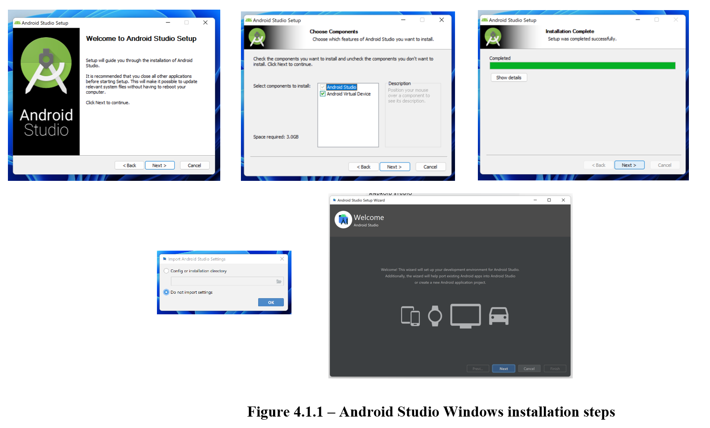
- If .exe file downloaded, double-click to start application.
If .zip file downloaded, extract the folder, copy the “android-studio” folder into your “Program Files” folder. Then open the “android-studio > bin” folder and launch “studio64.exe”.
- Follow the Android Studio Setup Wizard and install the recommended software development kit (SDK) packages.
MacOS:
System Requirements: MacOS 10.14 (Mojave) or higher, Advanced RISC (Reduced Instruction Set Computer) Machine (ARM)-based chips or 2nd generation Intel Core or newer, minimum 8 GM RAM, minimum 8 GB available disk space, minimum 1280 x 800 screen resolution
Packages:
- 64-bit
- 64-bit, ARM
Installation:
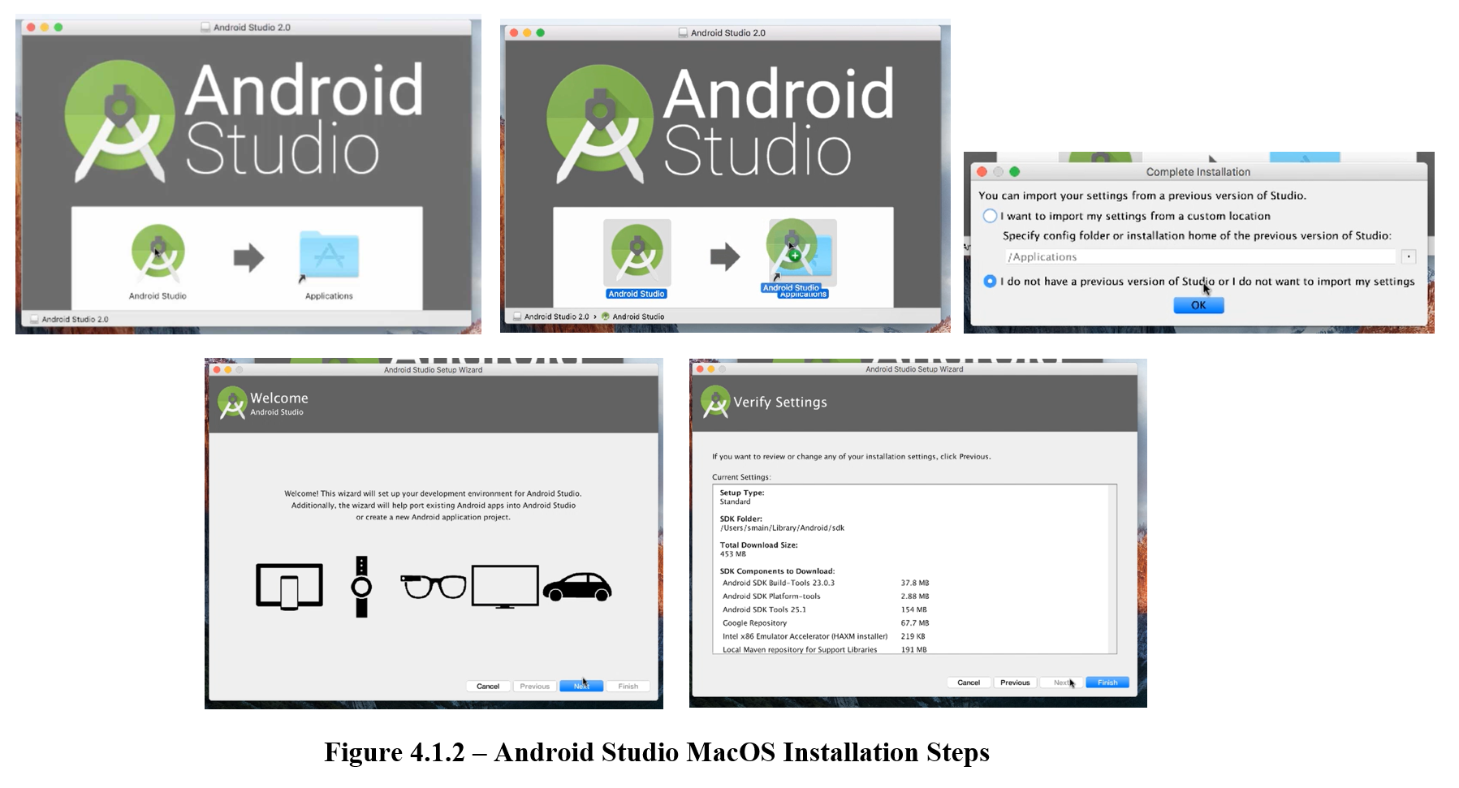
- Launch the Android Studio disk image (DMG) file.
- Drag and drop the Android Studio icon into the Applications folder.
- Launch Android Studio.
- Select whether you want to import previous Android Studio settings, then click the “OK” button.
- Follow the Android Studio Setup Wizard and install the recommended SDK packages.
Linux:
System Requirements: Any 64-bit Linux distribution that supports Gnome, KDE, or Unity DE, x86_64 CPU architecture, 2nd generation Intel Core or newer, minimum 8 GM RAM, minimum 8 GB available disk space, minimum 1280 x 800 screen resolution.
Packages:
- 64-bit
Installation:
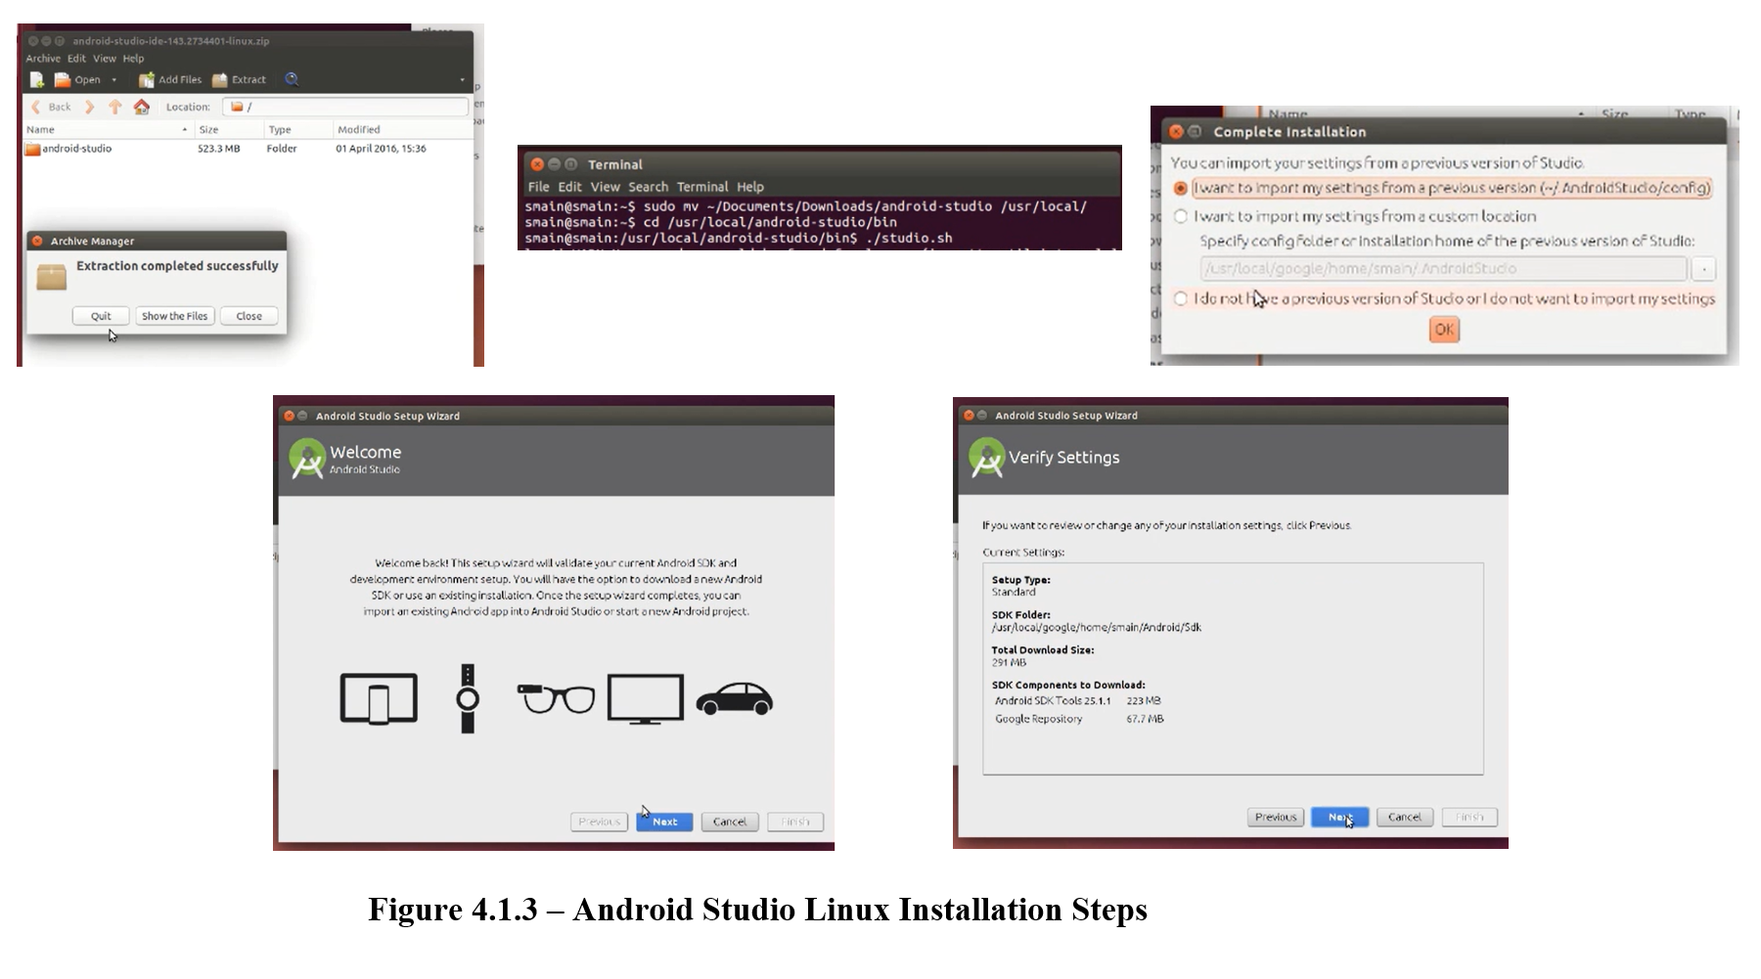
- Unzip the zip file to an appropriate location for your applications.
- To launch, open a terminal, navigate to the “android-studio/bin/” directory, and execute “studio.sh”.
- Select whether you want to import previous Android Studio settings, then click the “OK” button.
- Follow the Android Studio Setup Wizard and install the recommended SDK packages.
Chrome OS:
System Requirements: Linus for Chrome OS, Intel i5 or higher recommended, minimum 8 GM RAM, minimum 4 GB available disk space, minimum 1280 x 800 screen resolution.
Packages:
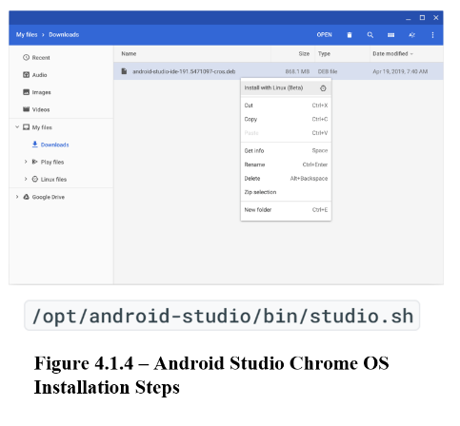
- Chrome
Installation:
- Right click the downloaded DEB file and select “Install with Linux (Beta)”.
- Select whether you want to import previous Android Studio settings, then click the “OK” button.
- Follow the Android Studio Setup Wizard and install the recommended SDK packages.
- To launch, either start from the Launcher, or from the Chrome OS Linux terminal by running “studio.sh” in the default installation directory: “/opt/android-studio/bin/studio.sh”.

Flutter and Dart
Flutter is an open-source UI SDK created by Google, used to develop cross platform applications for Android, iOS, Linux. MacOS, Windows, Google Fuchsia and the web using a single code base. Dart is a programming language, also developed by Google, designed for web and mobile applications.
Flutter:
Windows:
System Requirements: Windows 10 or later, 1.64 GB available disk space, Windows PowerShell 5.0 or newer, Git for Windows 2.x, with the “Use Git from Windows Command Prompt” option.
Installation:
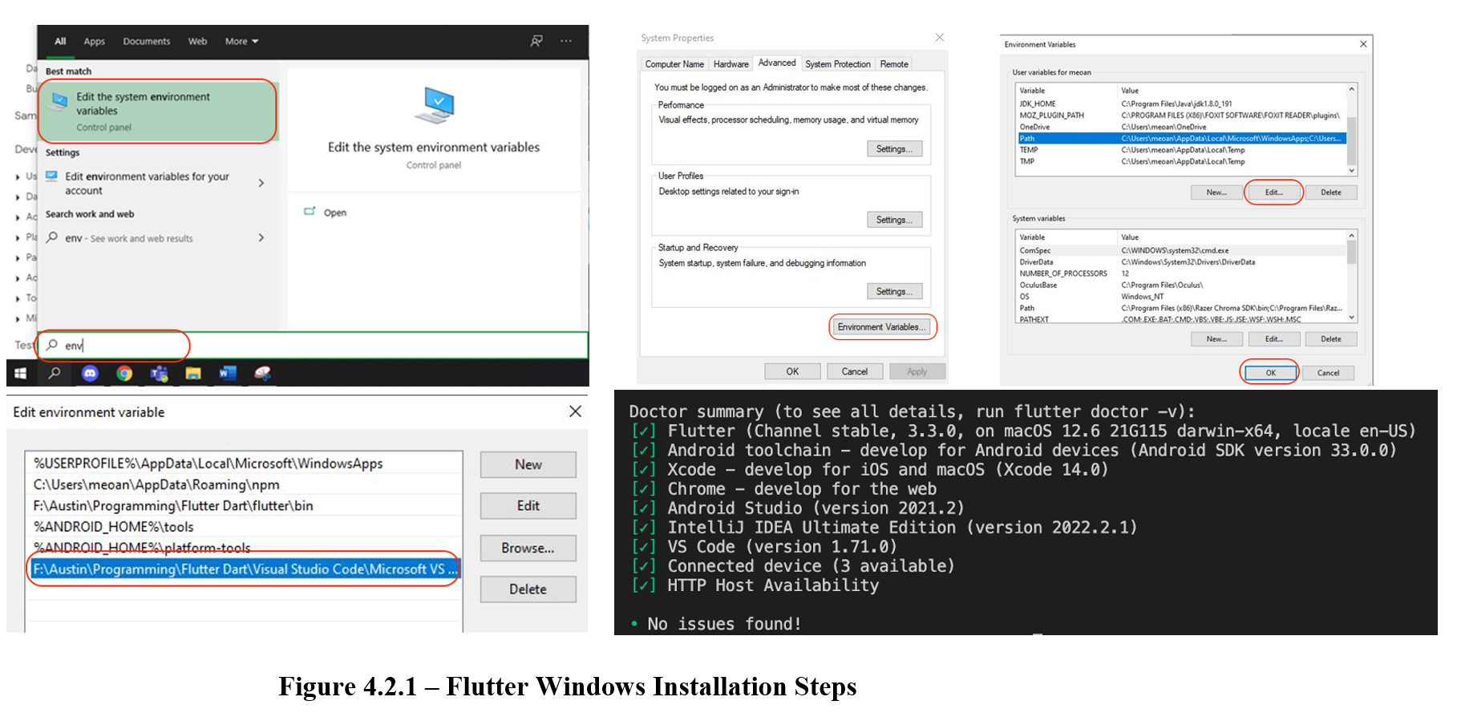
- Download the latest stable release of the Flutter SDK
- Extract the zip file and place the contained “flutter” in the desired installation directory
- Update the path to run flutter commands from the Windows console
  - From the search bar, enter ‘env’ and select “Edit Environment Variable for your account’
  - Under “User variables” check if there is a “Path”
    - If there is, append the full to path to “flutter/bin” using a “;” as a separator
    - If there isn’t, create a new user variable named “Path” with the full path to “flutter/bin”
- Close and reopen any console window for changes to take effect.
- From a console window, run “flutter doctor” to find any dependencies you need to complete setup
  - Check output for other software needed to be installed or further tasks to perform (in bold)
- Once missing dependencies have been installed, run “flutter doctor” again to confirm.
Detailed instructions: https://docs.flutter.dev/get-started/install/windows
MacOS:
System Requirements: macOS, 2.8 GB available disk space, git
Installation:
- Download the latest stable release of Flutter SDK
- Extract the file in the desired location
- Add flutter tool to path
- Run “flutter doctor” to see if there are any dependencies that need to be installed
  - Check output for any other software needed or further tasks to perform
- Confirm all dependencies have been installed by again running “flutter doctor”
Detailed instructions: https://docs.flutter.dev/get-started/install/macos
Linux:
System Requirements: Linux (64-bit), 600 MB available disk space, tools: bash, curl, file, git 2.x, mkdir, rm, unzip, which, xz-utils, zip
Installation:
- Download the latest stable release of Flutter SDK
- Extract the file in the desired location
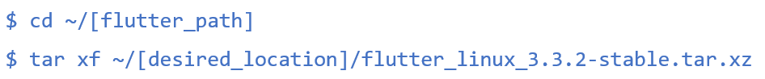
- Add flutter tool to path
- Run “flutter doctor”
- Installed needed dependencies found in output
Detailed instructions: https://docs.flutter.dev/get-started/install/linux
Chrome OS:
System Requirements: Chrome OS (64-bit) with Linux (Beta) turned on, 600 MB available disk space, tools: bash, curl, git 2.x, mkdir, rm, unzip, which, xz-utils
Installation:
- Download the latest stable release of Flutter SDK
- Drag and drop the downloaded file from “Downloads” to “Linux Files”
- Extract the file in the desired location

- Add flutter tool to path
- Run “flutter doctor”
- Install needed dependencies found in output
Detailed instructions: https://docs.flutter.dev/get-started/install/chromeos

Android Emulator
Android Emulator allows users to simulate Android devices so that the application can be tested on multiple Android devices without having to have the actual devices. This emulator provides almost all the capabilities and functionality of the actual device, so the application can be tested in multiple situations.
Installation: Android Emulator comes with Android Studio by default.
System Requirements: 64-bit Windows, macOS, or Linux operating system, 16 GB RAM, and 16 GB available disk space.
Setup:
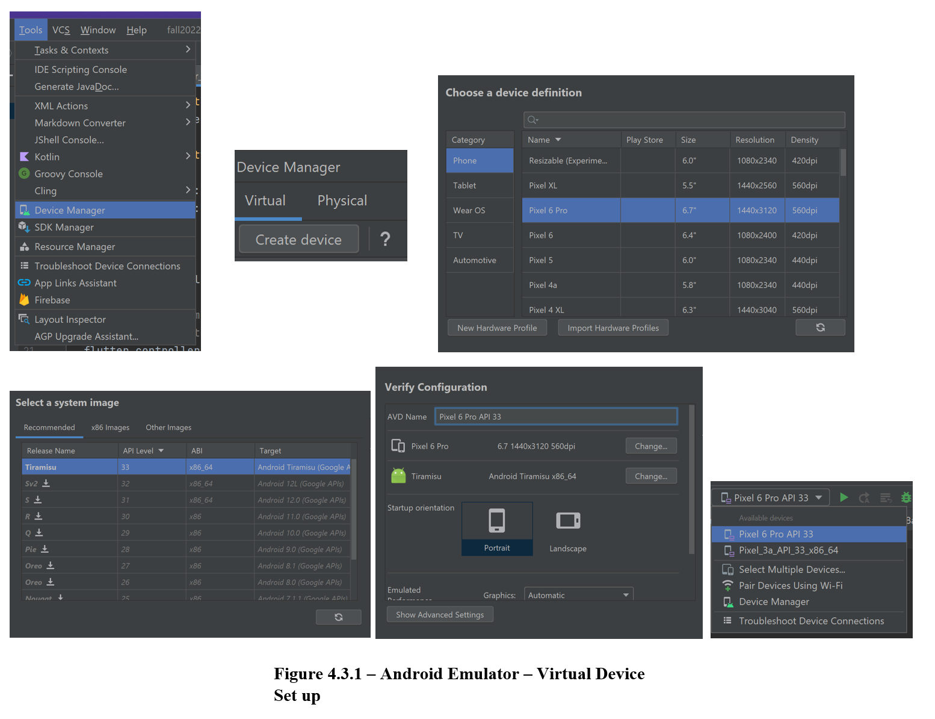
- Create an Android Virtual Device (AVD) with the desired Android version and hardware specifications. This can be done by:
  - Opening the “Device Manager”.
  - Click the “Create Device” button.
  - Follow the setup to select the desired hardware and system image
- Run the application on the emulator by selecting the desired AVD from the target device drop-down menu and clicking the “Run” button.

GitHub Desktop
GitHub will be used as the code repository.
System Requirements: Windows 7 (64-bit) or later, MacOS 10.12 or later
Installation:
- Download the current version of GitHub from https://desktop.github.com/
- In your computer’s “Downloads” folder, double-click the “GitHubDesktopSetup” file (Windows) or the “GitHubDesktop” zip file, unzip, and then click “GitHubDesktop” file
- Follow setup instructions

Prepare Mobile Application for Use

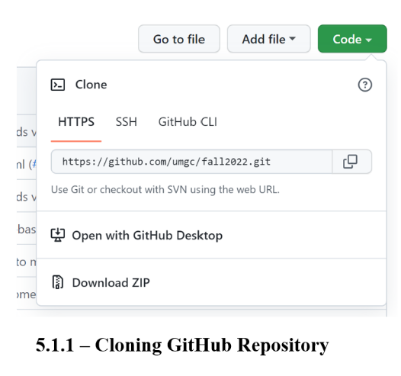
Cloning the GitHub Repository
To clone the GitHub repository:
- Navigate to https://github.com/umgc/fall2022
- Click the green “Code” button
- Select the “HTTPS” option
- Click “Download ZIP”

Run the Flutter Application
To run the cloned flutter application on a device:
- Unzip cloned application code
- Open Android Studio
- Import the project (File > New > Import Project)
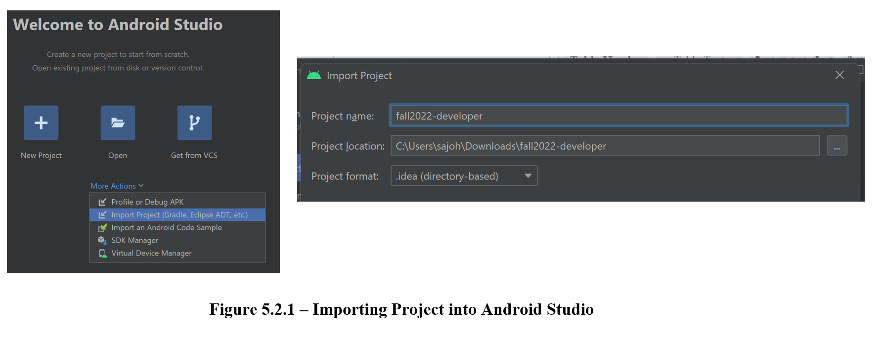

Setting up an Android Device
It is crucial that the application is also tested on Android devices. Using Android Studio, an Android device can be set up to run the application, using either a USB or Wi-Fi.
Setup:
- On the device, open the “Settings” app, select “Developer Options”, then enable “USB debugging” (if connecting with a USB).
  - If “Developer Options” is not enabled, go to “Settings > About Phone > Build Number” and tap the “Build Number” option 7 times.
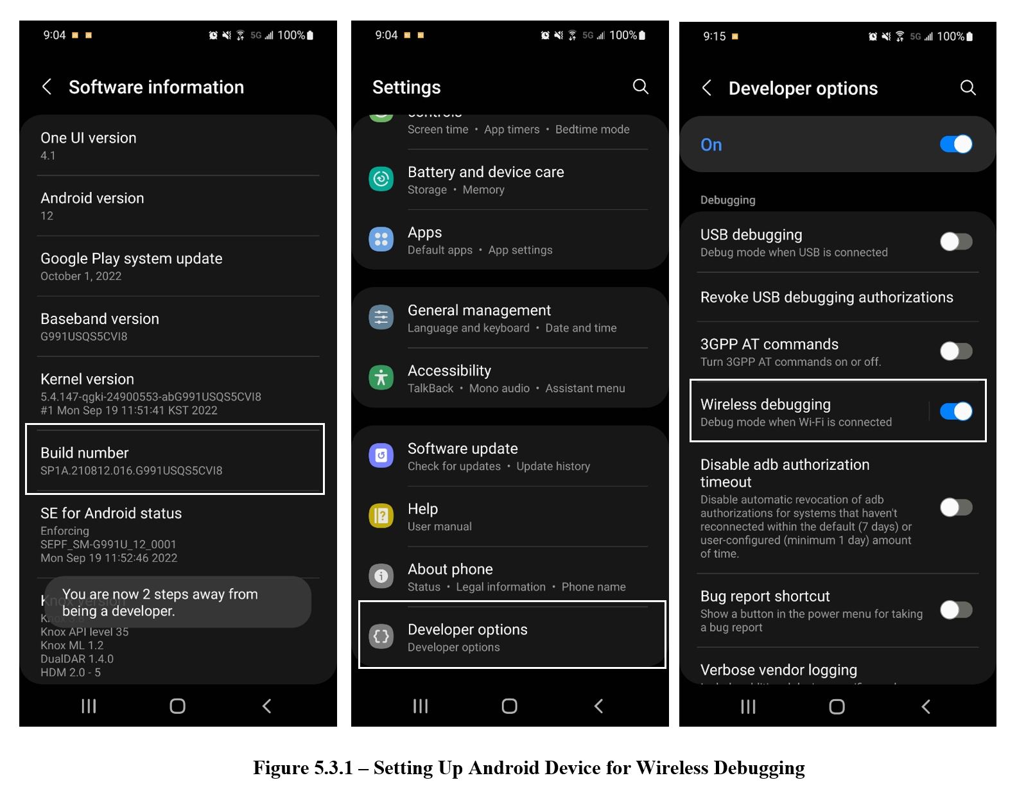
- Setup your system to detect the device.
  - Chrome OS and macOS: no additional configuration required.
  - Windows: install a USB driver for ADB (if using a USB to connect device). Instructions found here.
  - Ubuntu Linux: each user needs to be in the plugdev group, and the system needs to have udev rule installed.
- Connect to device using USB:
  - Once the device has been plugged in using a USB, click the “Run” button in Android Studio to build and run the application on your device.
- Connect using Wi-Fi:
  - Ensure the device is running Android 11 or higher.
  - Ensure you have the “Canary” version of Android Studio and update to the latest version of “SDK Platform-Tools".
  - Open Android Studio and select “Pair Devices Using Wi-Fi" from the run configurations drop-down menu.
  - Enable “Pair device with QR code” by going to “Settings > Developer Options > Wireless Debugging > Pair device with QR code”, and scan the QR code on the screen.
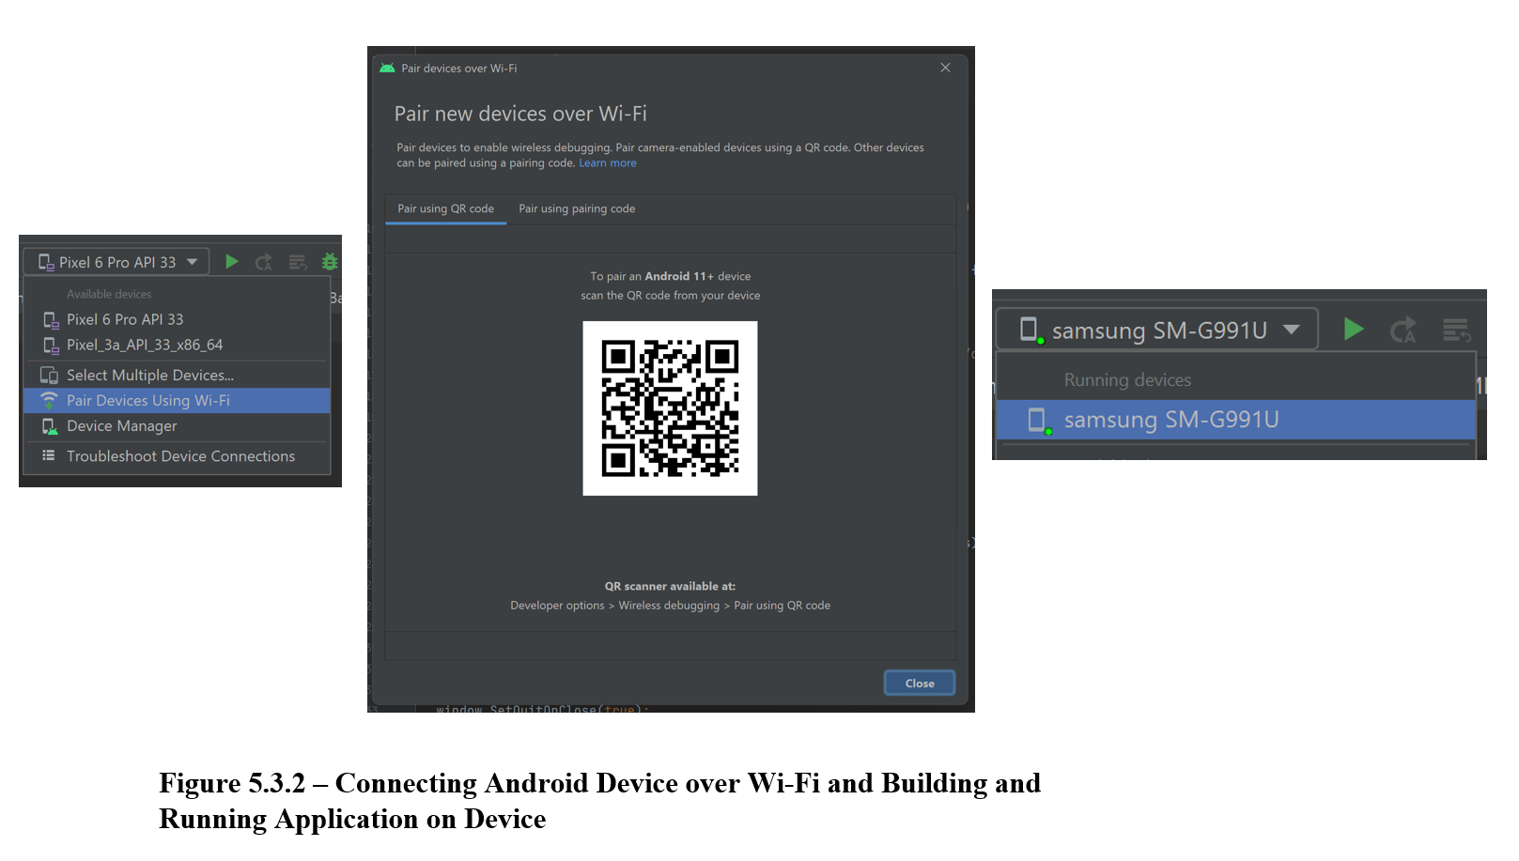

Setting up an iOS Device
To deploy an application to a physical iOS device, a physical device deployment in XCode needs to be set up. It is assumed that the user has an existing Apple ID which will be used as an Apple Developer account to access a limited set of developer-oriented privileges for free.
Setup:
- Open the applications ios workspace in Xcode. This is found in “ios/Runner.xcworkspace”.
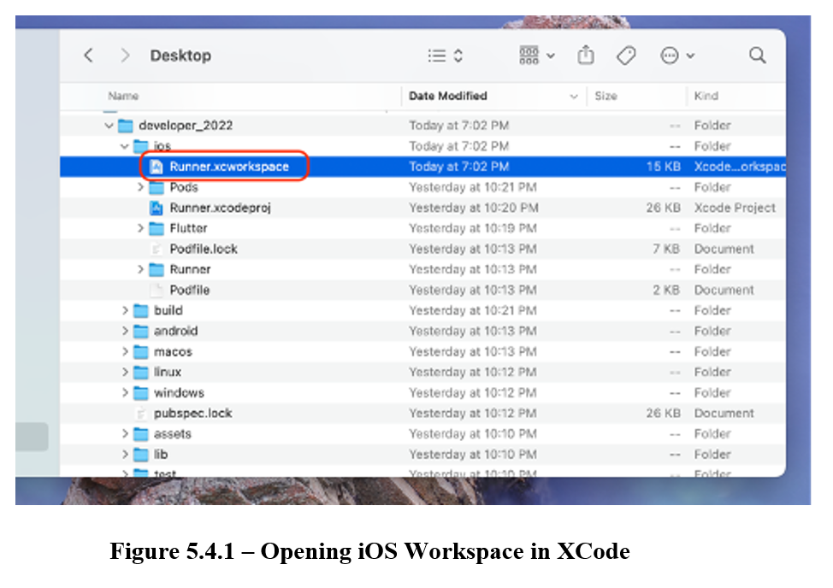
- Connect the iOS device to the computer using a USB.
- Click on the “run destination menu” in the toolbar and select the connected device.
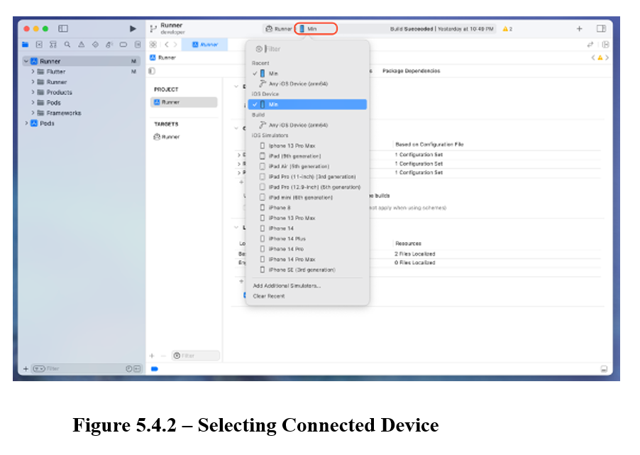
- In the project navigation, select the “Runner” target, then select the “Signing & Capabilities” tab.
- Check the “Automatically manage signing” checkbox.
- For “Team” select the Development Team.
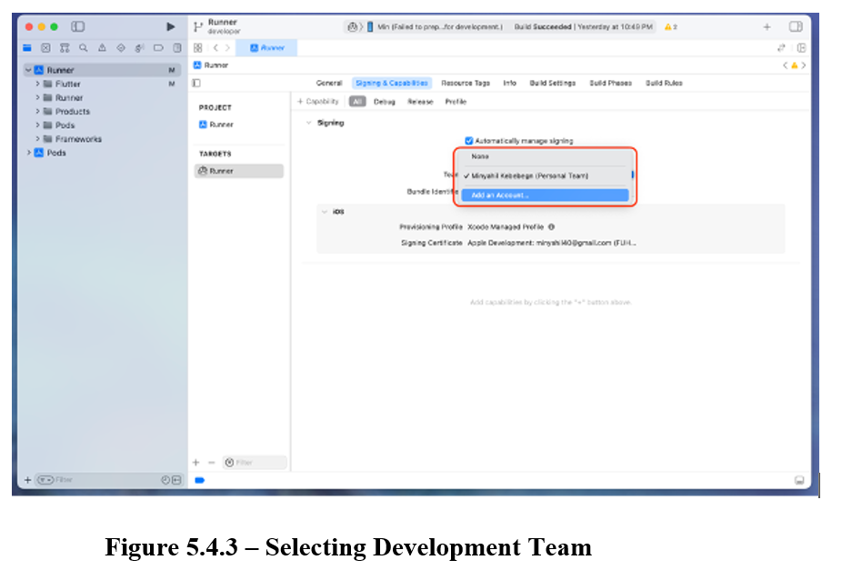
- If necessary, provide a unique “Bundle Identifier”, e.g. com.example.fall2022.
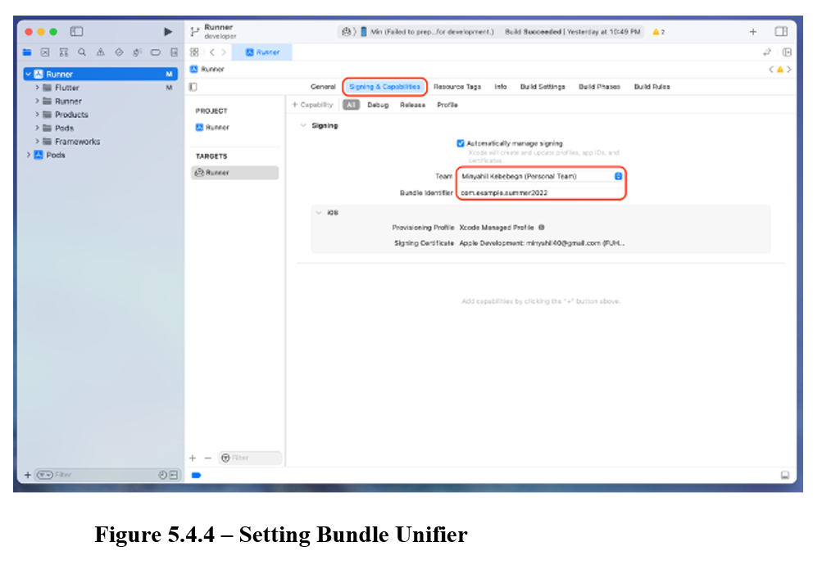
- Under the “General” tab, update the application’s display name in the “Identity” section.
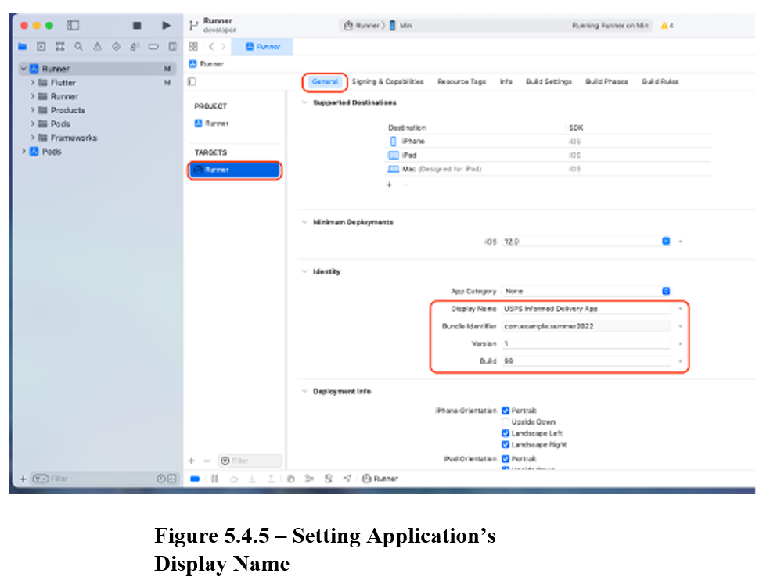
- Click the “Run” button to build and deploy the application to the connected device.
- The first time the application is deployed to the device, the application must the trusted by the device:
- On the device, navigate to the “Settings > General > VPN & Device Management” section
- Under “Developer Apps”, click “Apple Development”, then “Trust Apple Development”.
- To enable developer mode, go to “Settings > Privacy & Security > Developer Mode” and toggle developer mode on.
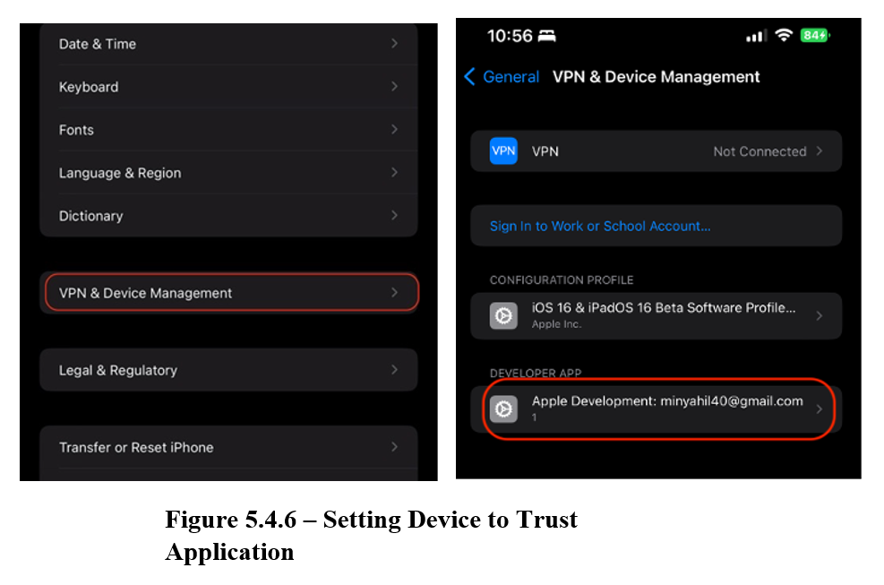

Deployment, Testing and Release of the Mobile Application

Google Play Store (Android)

Deploying to Google Play Store (Android)
The CI/CD pipeline allows building and publishing to the Google Play Store as a draft for review and testing by the specified team. Once the test team has been configured, they can be assigned to a draft and follow the provided link to download the application onto their devices from the Google Play Store.
To configure the list of tests, navigate to Internal Testing on the Google Play Console and select the Testers tab as shown in Figure 6.1. Selecting the team will assign them to the test application making it available for download. Selecting the arrow to the right of the row will allow management of the team members.
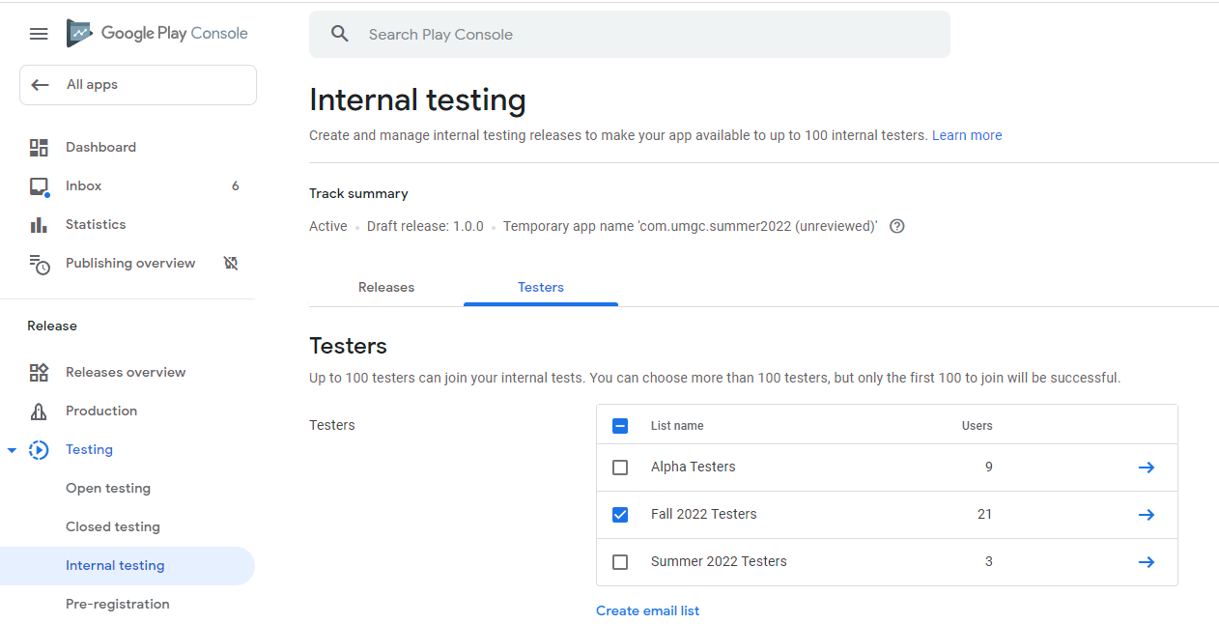
Figure 6.1.1 - Google Play Console Tester Specification
In order to get the CI/CD pipeline automatically releasing to the Google Play Console, a few steps must be followed. Note: Some of these steps may already be completed, but use this list to follow if issues arise with the current process.
- Generate Java Key Store (jks) file for signing the application (https://developer.android.com/studio/publish/app-signing#generate-key)
- Add the generated jks file to the repository (android/app/) and point to it in the key.properties file (android/key.properties) via the storeFile parameter
- Add the specified password in GitHub Secrets for KEYSTORE_PASS and KEYSTORE_KEY_PASS (this values get set during the CI/CD pipeline)
- Using pc-api credentials for the Google Play Console service account (must be provided by account owner, in this case the professor), set the SERVICE_ACCOUNT_JSON secret
- Run the GitHub pipeline to release a draft version of the application. If there are any pending drafts they may need to be discarded (especially if new service account credentials are being used)
- Once the draft is set for internal testing, a link can be sent to the approved testers so they can download the application via the Google Play Store and begin testing

Promoting Releases
After testing has completed on the internal track, the release can be promoted to closed alpha testing, and then onto open testing/release tracks.
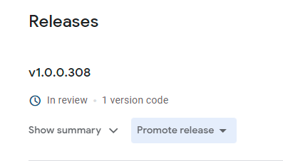
Figure 6.1.2 - Promote Release

Viewing Errors with Release
Viewing the Pre-launch report will display any issues with the release that must be fixed before a production promotion can be performed.
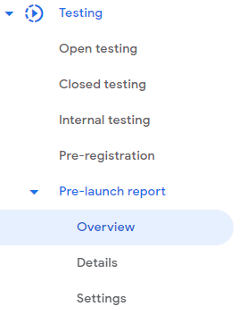
Figure 6.1.3 - Pre-launch report
Issues can be reviewed on this overview page to get more detailed descriptions as shown in Figure 6.1.3
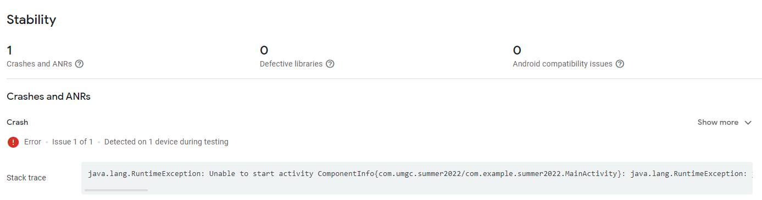
Figure 6.1.4 -Fixing issues

App Store Connect (iOS)

Deploying to App Store Connect (iOS)
Deploying an iOS app to App Store Connect will allow to:
- Invite users for testing on TestFlight
- Release the app on the App Store
To deploy an iOS app to the App Store Connect enrollment into the paid type of the Apple Developer Program is required. This will allow the creation of the provisioning profiles and certificates for app signing.
General steps to deploy an app for testing and further release include:
- Create a record for a new app in the App Store Connect
- Using XCode to archive and upload the app to the App Store Connect

Create a record for a new app in the App Store Connect
To create a record for the app in the App Store connect go to https://appstoreconnect.apple.com/ and log in with Apple ID that was used to enroll into the Apple Developer Program or Apple ID that was added to the account in a specific role.
On the main page select “My Apps” (Figure 6.2.1)
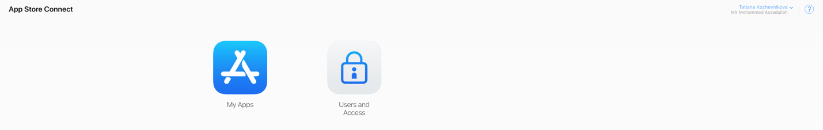
Figure 6.2.1 - Main Page App Store Connect
On the App page click “+” and select “New App” as shown in Figure 6.6
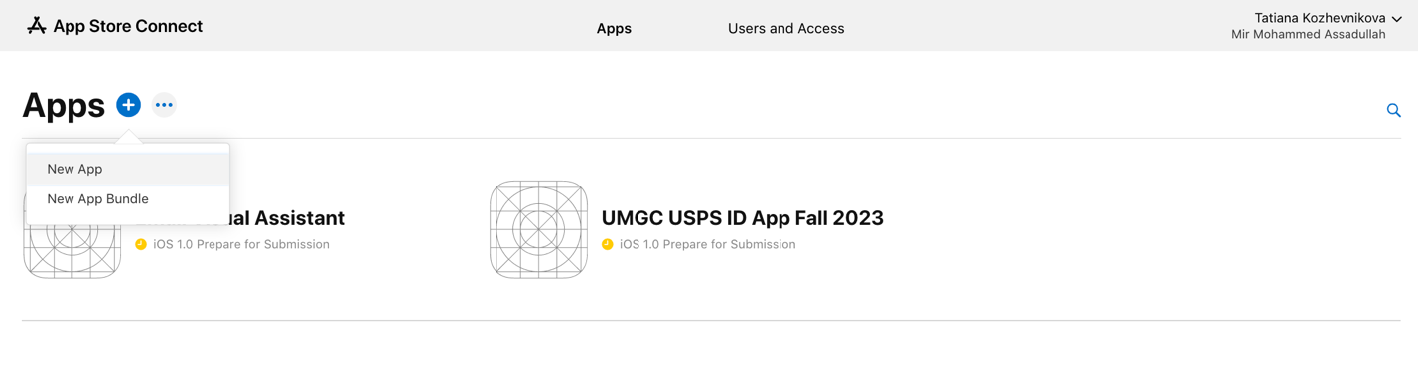
Figure 6.2.2 - Apps Management
In the “New App” dialog populate all required fields (Figure 6.2.3).
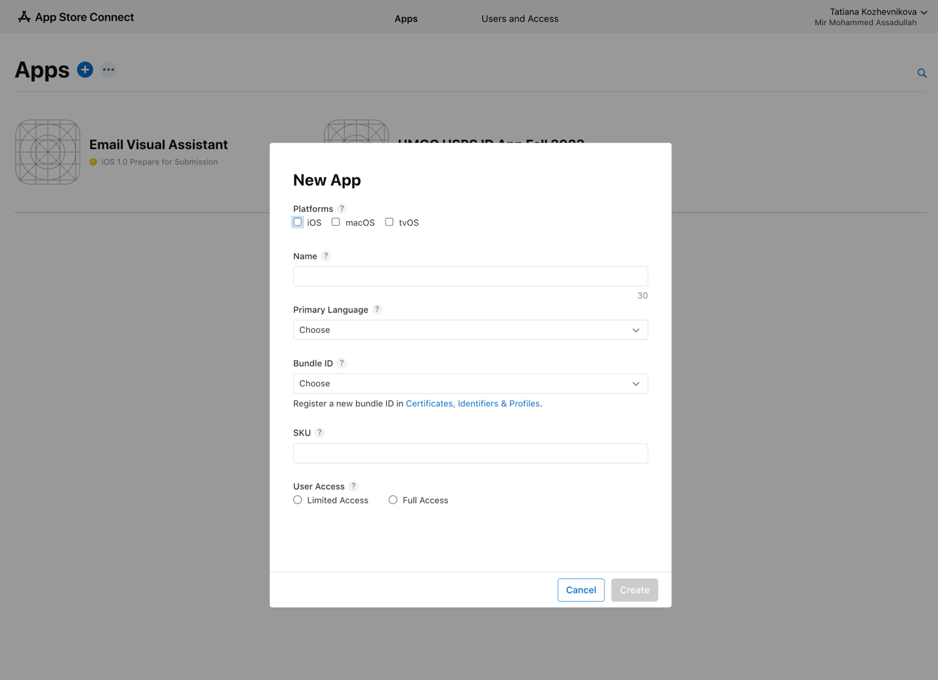
Figure 6.2.3 - Create New App
The new app record is created, and all information can be accessed by clicking on the app (Figure 6.2.4)
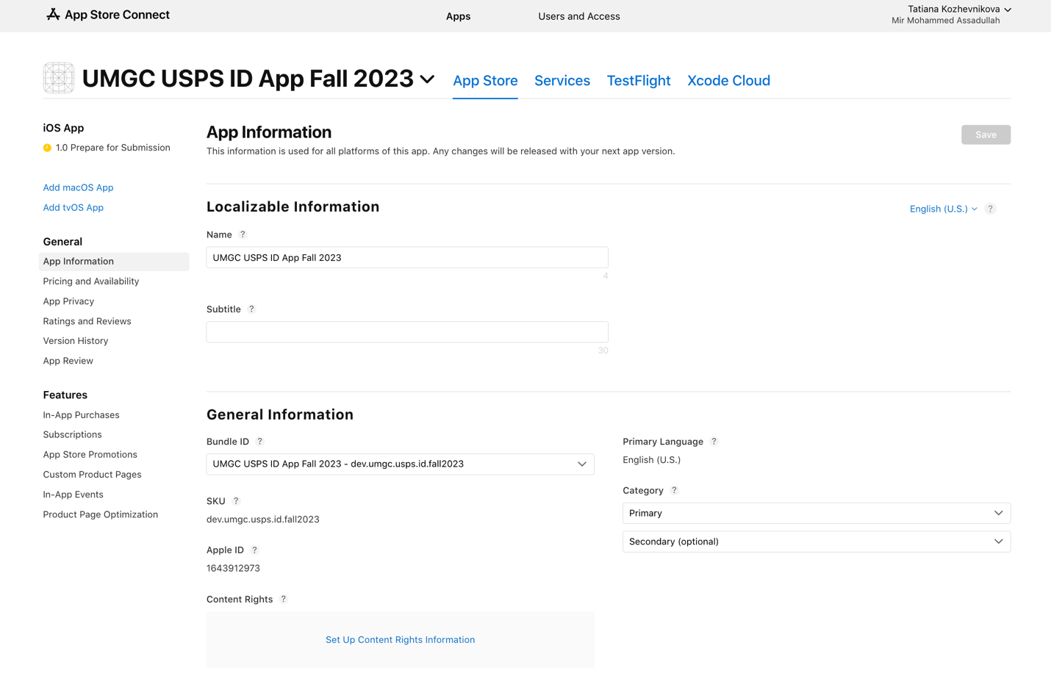
Figure 6.2.4 - App Details

Using XCode to archive and upload the app to the App Store Connect
Open the app in the XCode and connect a physical device. Select “Automatically manage signing”, choose a valid development account and confirm that “Bundle Identifier” matches the bundle ID from the app record in the App Store Connect (Figure 6.2.5). To properly update bundle ID change the corresponding value in Info.plist.
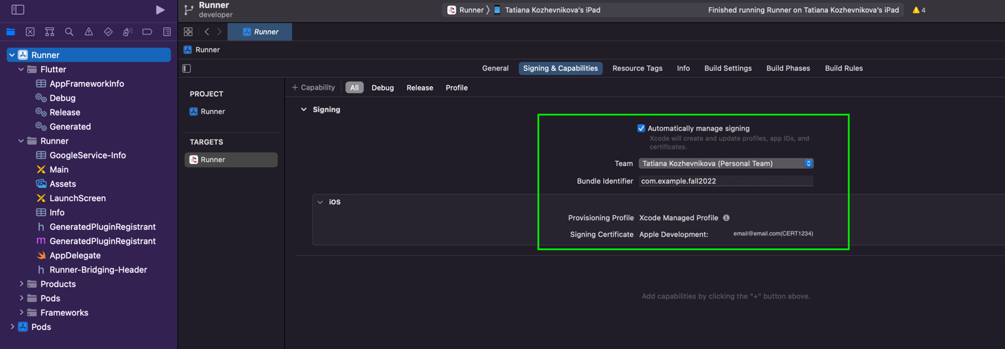
Figure 6.2.5 - Signing Profile Setup
In the top menu click “Product” and select “Archive” (Figure 6.2.6). The archiving process has been started, which may take a couple of minutes.
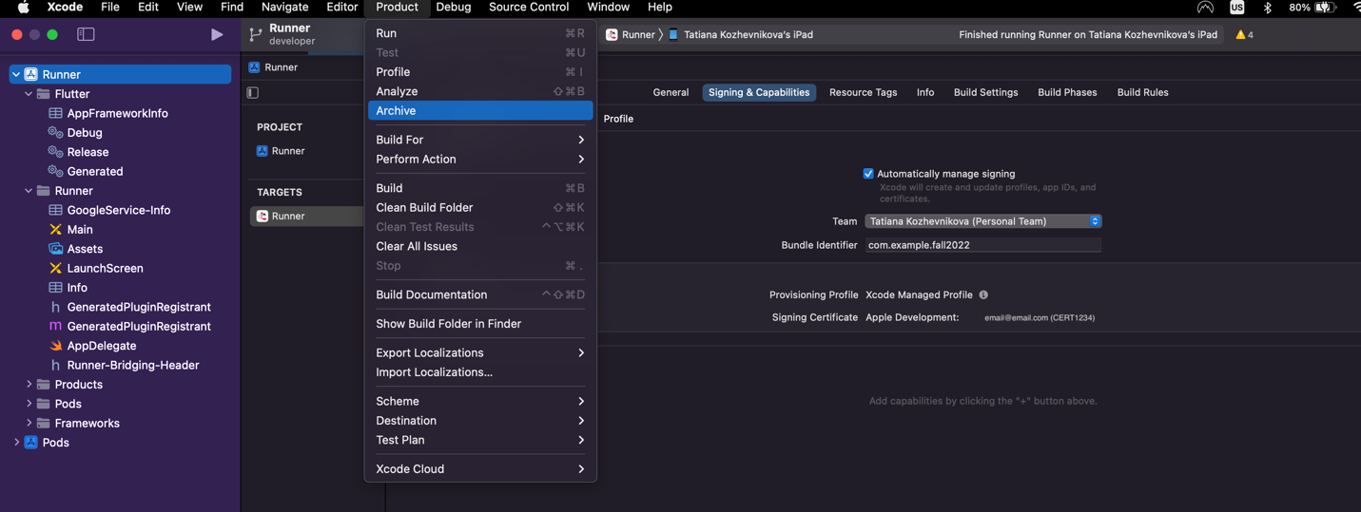
Figure 6.2.6 - App Archiving Process
Successfully completed archiving process will result in the creation of the archive file and will display it in the “Archives” window as shown in Figure 6.2.7
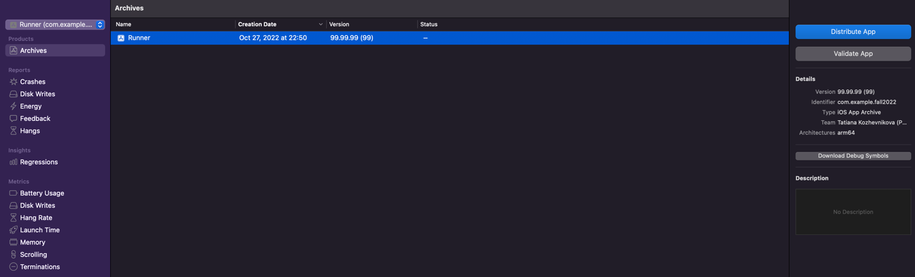
Figure 6.2.7 - Archives Ready for Distribution
Click the “Distribute App” button to proceed with the deployment process. A prompt with options for distribution methods are presented (Figure 6.2.8). Select “App Store Connect” for distribution on TestFlight and App Store.
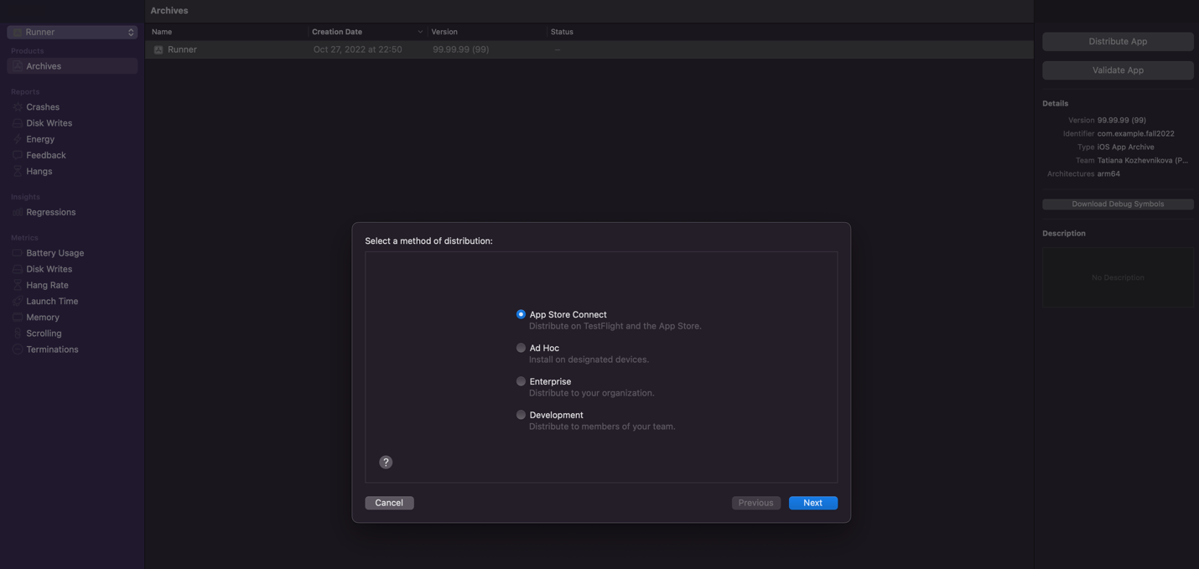
Figure 6.2.8 - Finalizing Distribution: Method Selection
In the next prompt select “Upload” as the app destination, which will send the app to App Store Connect (Figure 6.2.9).
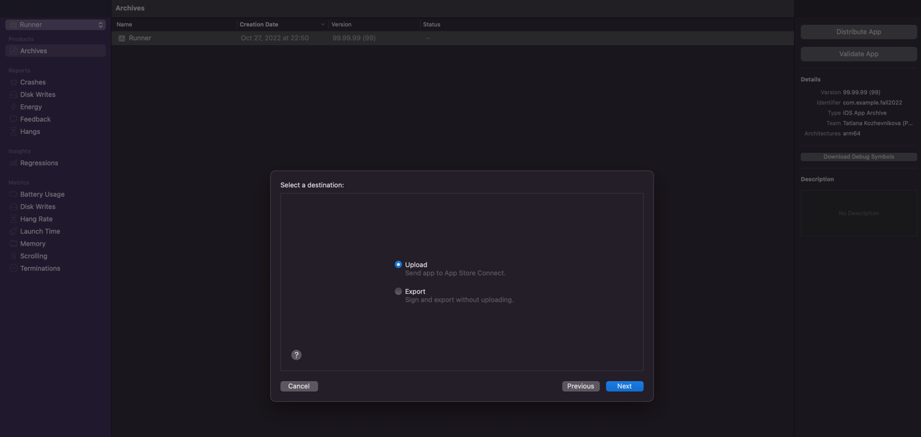
Figure 6.2.9 - Finalizing Distribution: Destination Selection
Further steps will be updated when the paid Apple Developer Program will be purchased. As current provisioning profile and certificate don’t allow App Connect Distribution.

Testing
When the app is uploaded to the App Store Connect it can be distributed for internal testing via TestFlight. In the App Store Connect select the app navigate to the “TestFlight” tab and click “+” next to “Internal Testing” (Figure 6.2.10).
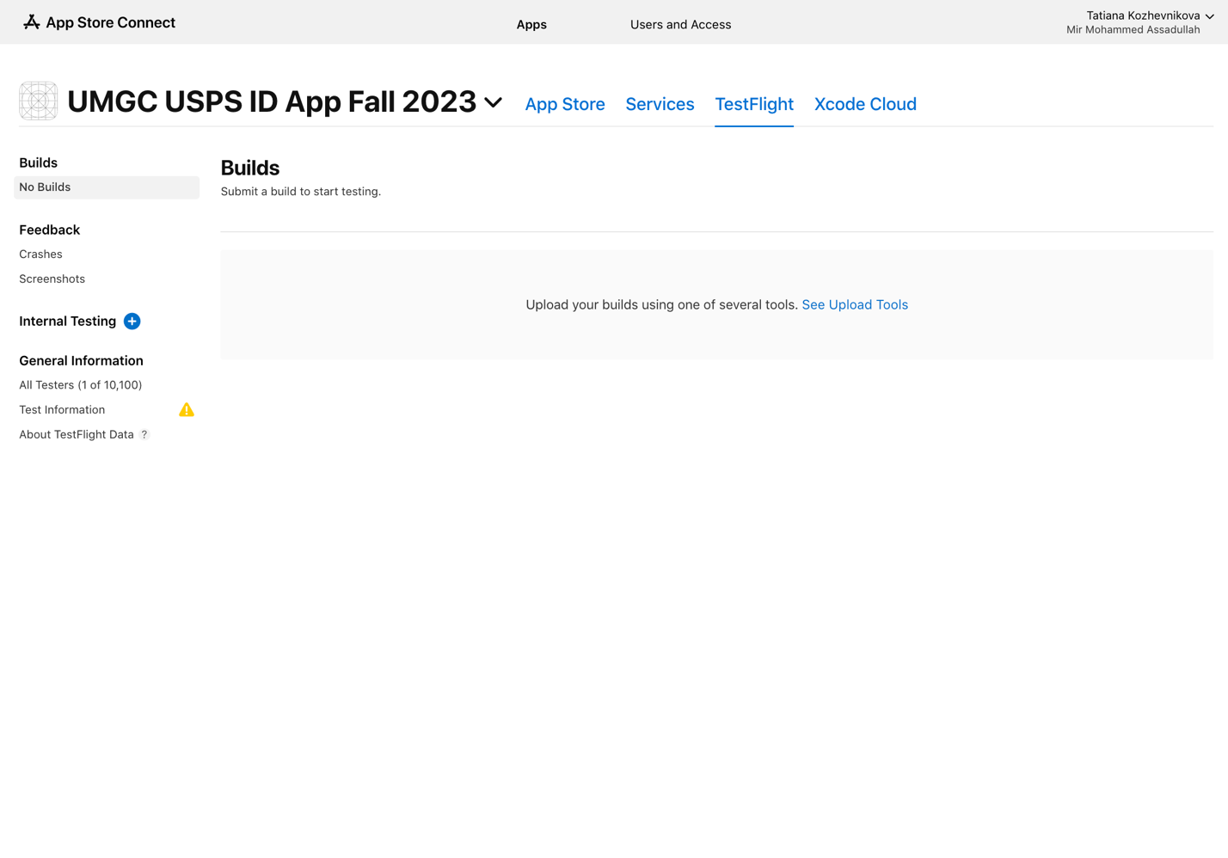
Figure 6.2.10 - Internal Testing Setup
Create new testing group and add testers as Figures 6.2.11 and 6.2.12 show respectively.
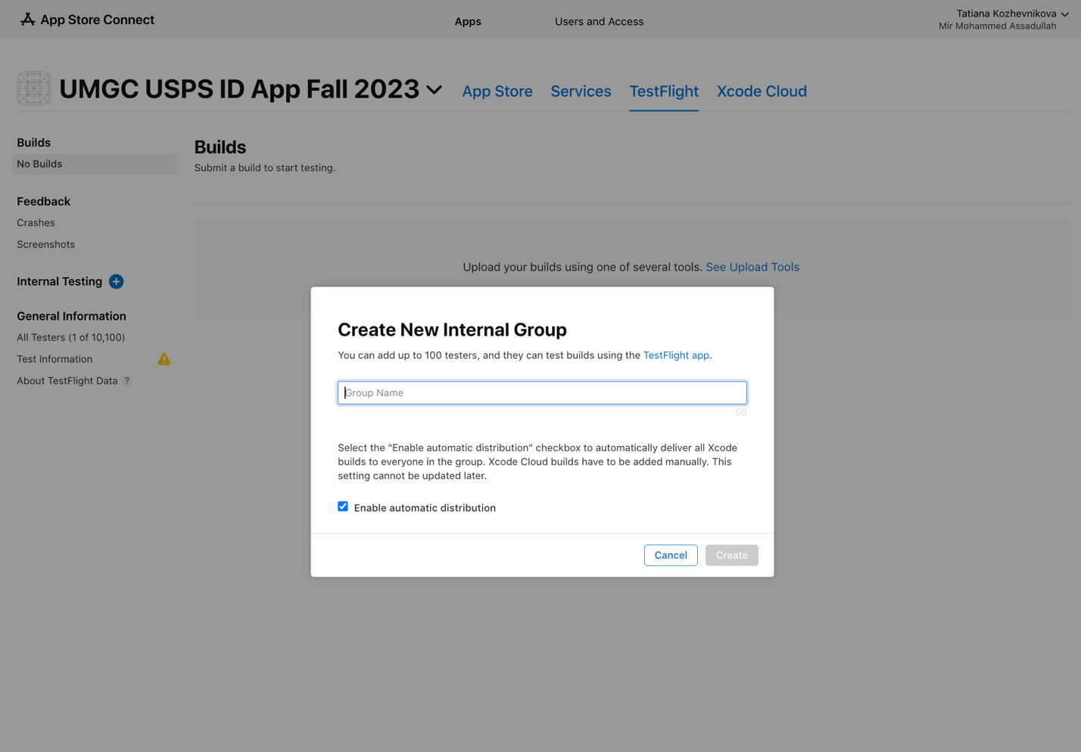
Figure 6.2.11 - New Testing Group Creation
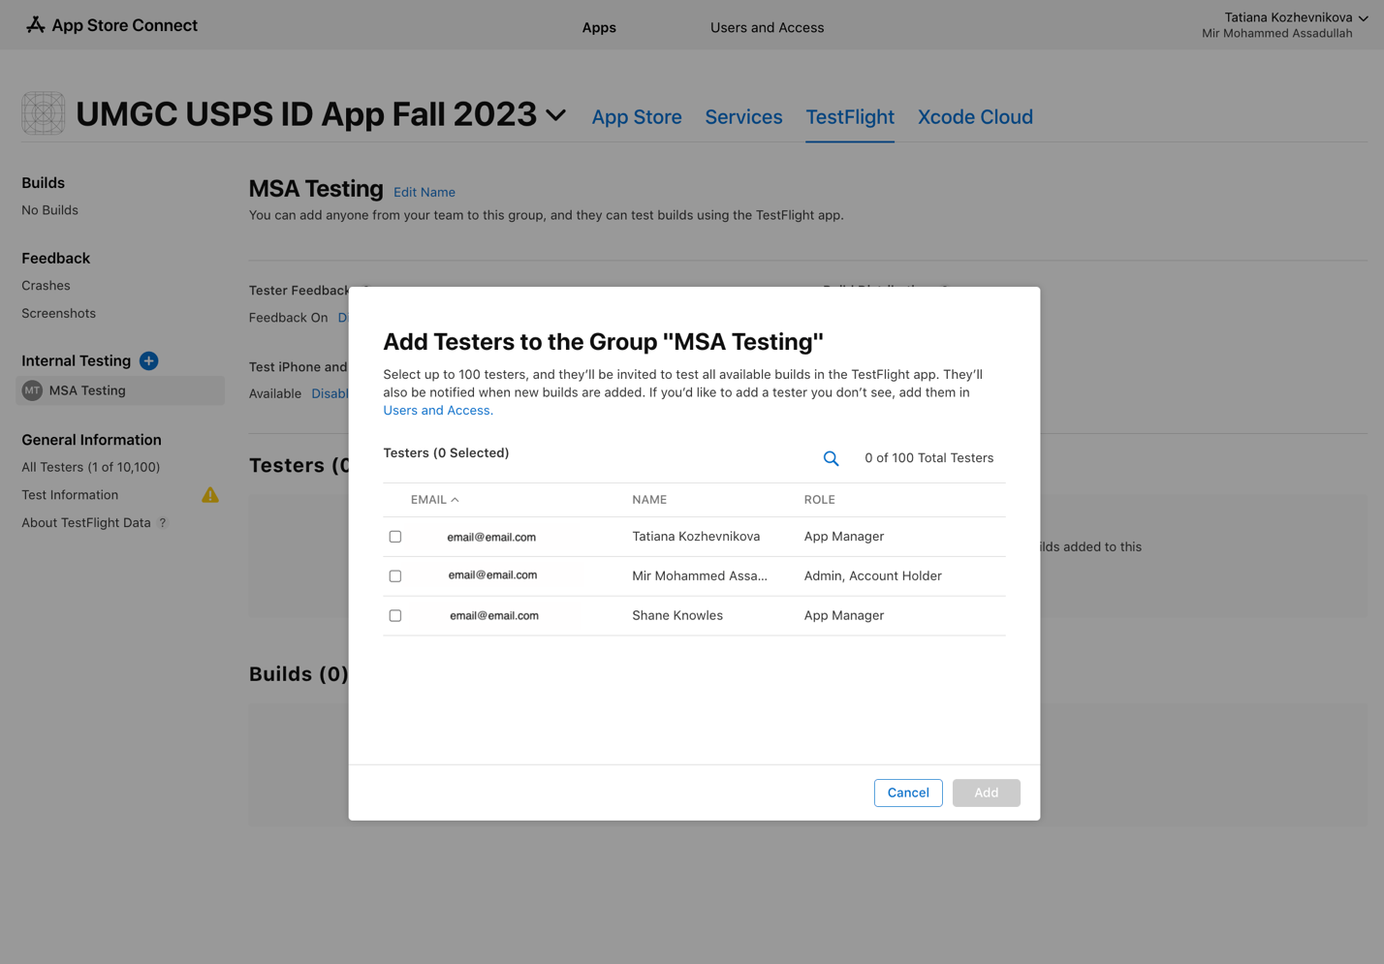
Figure 6.2.12 - Adding Tester to the Testing Group
Testers are added to the testing group (Figure 6.2.13), now they can download the app through TestFlight and will get automatic app updates whenever the new build is released.
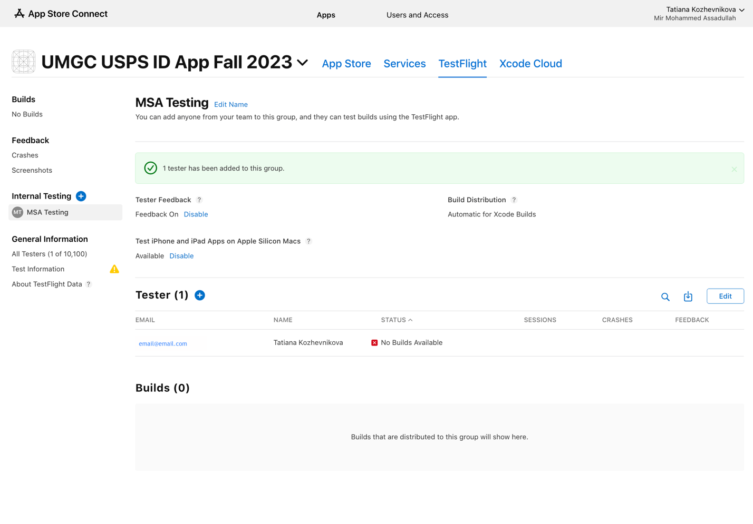
Figure 6.2.13 - Internal Testing Group View

Troubleshooting
This section will cover the common issues users might run into as they are developing and testing the application.

Emulator Freezing
Perform a cold boot:
- In Android Studio, open the “Android Manager” by either clicking the icon in the top ribbon or click on “Tools > Android Manager”.
- Select the emulator that has frozen and click the down arrow in the “Actions” column.
- Select “Cold Boot Now”.
It is recommended to perform a cold boot after any type of troubleshooting is performed to clear the RAM of internal data.

Emulator Not Responding
Wipe emulator data and return it to its original state:
- If emulator is running, stop/exit the emulator.
- In Android Studio, open the “Android Manager” by either clicking the icon in the top ribbon or click on “Tools > Android Manager”.
- Select the emulator that has frozen and click the down arrow in the “Actions” column.
- Select “Wipe Data” and perform a cold boot

Out of Memory
Free up virtual memory and increase assigned memory:
- Close all unnecessary applications running in the background.
- In Android Studio, open the General Settings: “File > Settings”.
- Go to the memory Settings: “Appearance & Behavior > System Settings > Memory Settings”
- Change the IDE max heap size to desired amount (2048 MB is recommended).
- Click “Apply” then “OK”.
- Restart Android Studio.

Dependency Errors
Clear Flutter build files and re-import libraries:
- Open Flutter terminal
- Navigate to directory of the Flutter project
- To clear dependencies, run “flutter clean” command
- Re-import the libraries to get the correct dependencies by running Flutter “Get dependencies” and “Upgrade dependencies”.

Appendix A – Acronyms and Abbreviations
Term | Meaning
ADB | Android Debug Bridge
ARM | Advanced RISC Machine
AVD | Android Virtual Device
CI/CD | Continuous Integration/Continuous Deployment
CPU | Central Processing Unit
DMG | Disk Image
DOG | Development and Operations Guide
DevOps | Development and Operations
DevSecOps | Development, Security & Operations
GB | Gigabytes
ID | Identification
IDE | Integrated Development Environment
iOS | iPhone Operating System
MacOS | Macintosh Operating System
MS | Microsoft
MSA | MailSpeak Application
OCR | Object Character Recognition
OS | Operating System
PM | Project Manager
PMP | Project Management Plan
QR | Quick Response
RAM | Random Access Memory
RISC | Reduced Instruction Set Computer
SDK | Software Development Kit
SE | Software Engineer
SWEN | Software Engineering
TBD | To Be Determined
UMGC | University of Maryland Global Campus
USB | Universal Serial Bus
USPS | United States Postal Service

Appendix B – Enabling Screen Reader on Android Device
- Open the Settings app
- Tap ‘Accessibility’ > ‘TalkBack’
- Enable ‘Use TalkBack’
- Go through tutorial until completion
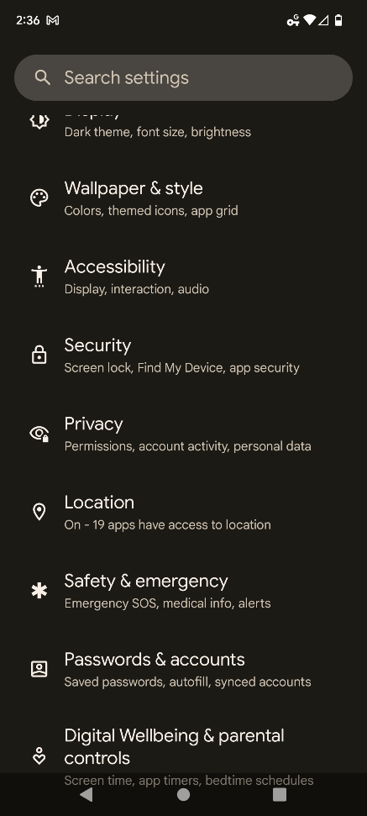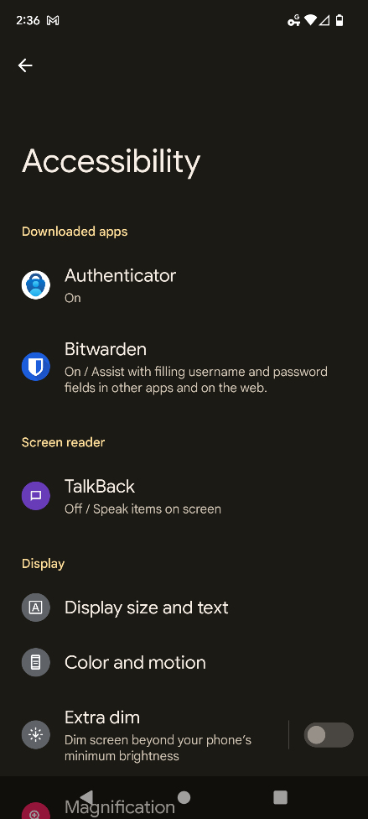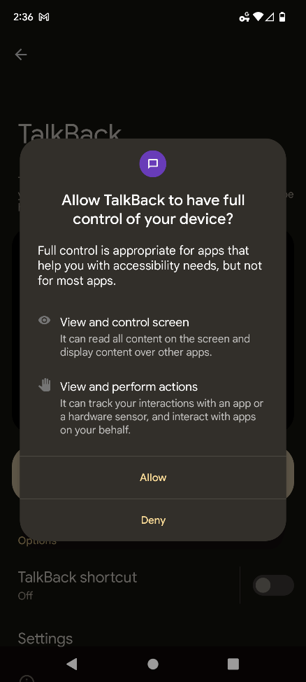

Appendix C – Enabling Screen Reader on iOS Device
- Go to ‘Settings’ > ‘Accessibility’ > ‘VoiceOver’
- Turn feature On/Off
- Alternatively, you can activate Siri and say ‘Turn on VoiceOver’
